Rodent trapping studies to understand the prevalence of zoonotic disease in West Africa: A scoping review.

2021-09-05

## Loading required package: pacman

# Introduction

* The role of zoonotic infectious diseases in human health and society have been dramatically highlighted through the ongoing SARS-CoV-2 pandemic and recent Ebola virus outbreaks in the Democratic Republic of Congo and Guinea.
* The number and intensity of zoonotic spillover events are projected to increase under anthropogenic pressure (e.g. increased human populations and increasing urbanisation) and global climate change (Morse et al. 2012).
* Rodents are abundant and diverse (Burgin et al. 2018), their widespread occurrence and proximity to human activity make the understanding of the effect of environmental change on their host-pathogen interactions vitally important.
* Rodents are important hosts of zoonotic disease. Of 2,220 extant rodent species, 244 (10.7%) are described as being reservoirs of 85 zoonotic pathogens (Han, Kramer, and Drake 2016). This is an example of an ecosystem disservice provided by rodents.
* Rodents, also provide important ecosystem services within their habitats, including, pest regulation and seed dispersal (Fischer et al. 2018).
* Rodents typically demonstrate “fast” life histories (Dobson and Oli 2007), these traits are also associated with a species being a reservoir of zoonotic diseases (Han et al. 2015), but see (Albery and Becker 2021). Further, these traits are prevalent in species that thrive in human dominated landscapes where they displace species that are less likely to be reservoirs of zoonotic disease (Gibb et al. 2020).
* West Africa has previously been identified to be at relatively high risk of emerging zoonotic infectious disease events from wildlife populations (Jones et al. 2008). Ongoing changes in land use and population demographics may lead to an increased burden from zoonotic diseases on human populations in West Africa.
* Rodents are implicated in the transmission pathways of several diseases in the region, including, Lassa fever, Schistosomiasis and Leptospirosis.
* Rodent trapping studies have been conducted in West Africa in order to identify novel potential zoonotic pathogens within rodents and to investigate the prevalence and burden of known pathogens within known rodent hosts (e.g. for Lassa fever (Fichet-Calvet et al. 2009) and Schistosomiasis (Catalano et al. 2020)).
* Our understanding of the associations between rodents and their pathogens at broader geographic scales are typically based on global datasets (e.g. PREDICTS, GIDEON and GBIF) that consolidate information obtained from multiple sources of information (Gibb et al. 2020; Smith et al. 2014; Pigott et al. 2014). These datasets lack the contextually rich information on the presence, absence, abundance and habitats of individual rodent species that is provided by individual rodent trapping studies (Bovendorp, MCCleery, and Galetti 2017).
* These datasets have been used to identify potential geographic hotspots where virus and host species diversity may be expected to be at its greatest and therefore quantify the risk of a zoonotic disease spillover event occurring within a defined region (Han, Kramer, and Drake 2016). However, there remains the potential for important confounding in these spatial distributions through bias generated by study design and selection of sampling sites.
* For example, systematically increased sampling (e.g. more intensive studies over longer time periods) or over-representation of certain habitats (e.g. periurban landscapes) could lead to an apparent association between locations and risk that is driven by these factors rather than an underlying host and virus association (Wille, Geoghegan, and Holmes 2021; Gibb et al. 2021).
* Conversely some regions may not be sampled adequately and therefore under-represented in these datasets due to sparse human populations or inaccessible habitats which may lead to proposing that these regions are at low risk of zoonotic disease spillover events.
* Here, we identify rodent trapping studies performed across West Africa and identify the location and habitat types in which they have been conducted, the pathogens assessed and the host-pathogen associations that have been reported in order to quantify the potential bias and to identify regions requiring further focussed investigation.

# Methods

## Literature search

* We conducted a search in Ovid MEDLINE, Web of Science (Core collection and Zoological Record), JSTOR, BioOne, African Journals Online, Global Health and the pre-print servers, BioRxiv and EcoEvoRxiv for the following terms as keywords, no date limits were set:
  1. Rodent OR Rodent trap*
  2. West Africa (or the individual countries)
     1. AND 2.
* We searched other resources including the UN Official Documents System, Open Grey, AGRIS FAO and Google Scholar using combinations of the above terms.
* We ran the search on 2021-03-01.
* We included studies if they met all of the following inclusion criteria; i) reported findings from trapping studies where the target was a small mammal, ii) described the type of trap used or the length of trapping activity or the location of the trapping activity, iii) included trapping activity from at least one West African country, iv) recorded the genus or species of trapped individuals, v) were published in a peer-reviewed journal or as a pre-print on a digital platform or as a report by a credible organisation.
* We excluded studies if they met any of the following exclusion criteria: i) reported data that were duplicated from a previously included study, ii) no full text available, iii) not available in English.
* One reviewer screened titles, abstracts and full texts against the inclusion and exclusion criteria. At each stage, a random subset (10%) was reviewed by a second reviewer.

## Data extraction

* We extracted data from eligible studies into a Google sheets document. Extracted variables included i) study identifiers; ii) study aims; iii) trapping methodology; iv) geolocation data; v) method of speciation; vi) trapping locations and dates; vii) trapped species; viii) number of trap-nights and ix) microorganisms/pathogens of interest. The data extraction tool is archived and available in Supplementary Material 1.

### Location of rodent trapping studies and habitats studied

* We extracted GPS locations for the most precise location presented (i.e. trap, trap-line, study site or study region). We extracted coordinates in the format reported and converted them to decimal degrees.
* We recorded the habitat classification scheme a study used (e.g. IUCN Habitat Classification Scheme (Version 3.1)). For studies not using standardised recording, the explicit description from of the habitat in which the trap was placed was extracted. For studies reporting multiple habitat types (e.g. rice field, corn field and vegetable garden) for a single trap, trap-line or trapping grid, a higher order classification of habitat type was recorded (e.g. agricultural land).

### Rodent presence, absence, abundance

* We mapped genus and species names to the species names used in the Global Biodiversity Information Facility (GBIF) taxonomy (Facility 2021)
* We extracted information on the presence, absence and number of trapped individuals. For studies reporting on all trapped individuals (i.e. not those only reporting on the presence of a specific species of interest), the pseudo-absence of a species reported as present elsewhere in the study was explicitly recorded as an absence at that trap location.

### Pathogen presence and absence

* We extracted data on all pathogens assayed in studies investigating rodents for potential zoonoses. The number of rodents tested and the number of positive or negative samples were recorded alongside the type of assay used (e.g. Polymerase Chain Reaction (PCR), Enzyme Linked ImmunoSorbent Assay (ELISA) or viral culture). If studies reported indeterminate results this was noted. Where possible, pathogens were identified to species level. However, where an assay only allowed for attribution to a family of viruses or bacteria, the higher order grouping was used (e.g. Arenaviridae for a PCR using a non-specific arenavirus primer).

## Analysis

### Location and habitats of rodent trapping to investigate potential biases

* We summarised the number of studies, the year in which trapping occurred and the country in which they were conducted.
* We used the GPS coordinates of single trap, trapping grid/line or study site and the number of trap nights to calculate trapping effort (trap night density) within level 2 administrative areas in West Africa.
* For studies not reporting the number of trap nights we imputed the number based on the median trap success rate from studies which reported the number of trap nights (matched to building or non-building based study sites). The median trap success rate for all rodents at a defined trap site was calculated separately for trap sites which included built environments and non-built environments. The number of rodents trapped at a trap site was then used in combination with these two values of trap success to impute the number of trap nights for trap sites with no reported trap nights.
* We summarised the habitat types of trap sites based on information reported in the study.
* For the subset of studies investigating rodent zoonoses we compared the location of trapping sites with SEDAC Global Population Density estimates for 2005, the median year studies were commenced. We used a Generalised Additive Model (GAM) incorporating a spatial interaction term to investigate the association of number of trap nights and human population density. The model structure was specified as below:
  + *trap night density* ~ *Tweedie*(log(Population density (2005)) + (Longitude * Latitude))
* We obtained land cover classifications from the European Space Agency Copernicus dataset at 300m2 spatial resolution (2005) we extracted the proportion of land cover classes within all regions of West Africa and all regions in which rodent trapping occurred for investigation of zoonotic diseases. We compared the proportion of possible land cover classes with those of regions where trapping occurred.
* We mapped the presence and absence of rodent species and compared this to the presence and absence reported by both GBIF and IUCN to give a measure of the extent of each species range in which they have been sampled.

### Rodent pathogen associations

* We summarised the presence and absence of microorganisms, the assays used, their host species and the locations from where the samples were obtained.
* We investigated the association between rodent species and the detection of potential pathogens. We report proportion of positive and negative tests for each species and pathogen pair.

# Results

## Included studies

* 4,282 relevant citations were identified, with 126 rodent trapping studies included in narrative synthesis.
* The earliest included studies were published in 1974 with increasing numbers of studies being performed annually since 2005.
* The median length of rodent trapping activity was one year (IQR 0-2 years). The median time from completion of rodent trapping to publication is 3 years (IQR 2-5 years) (see Figure 1).

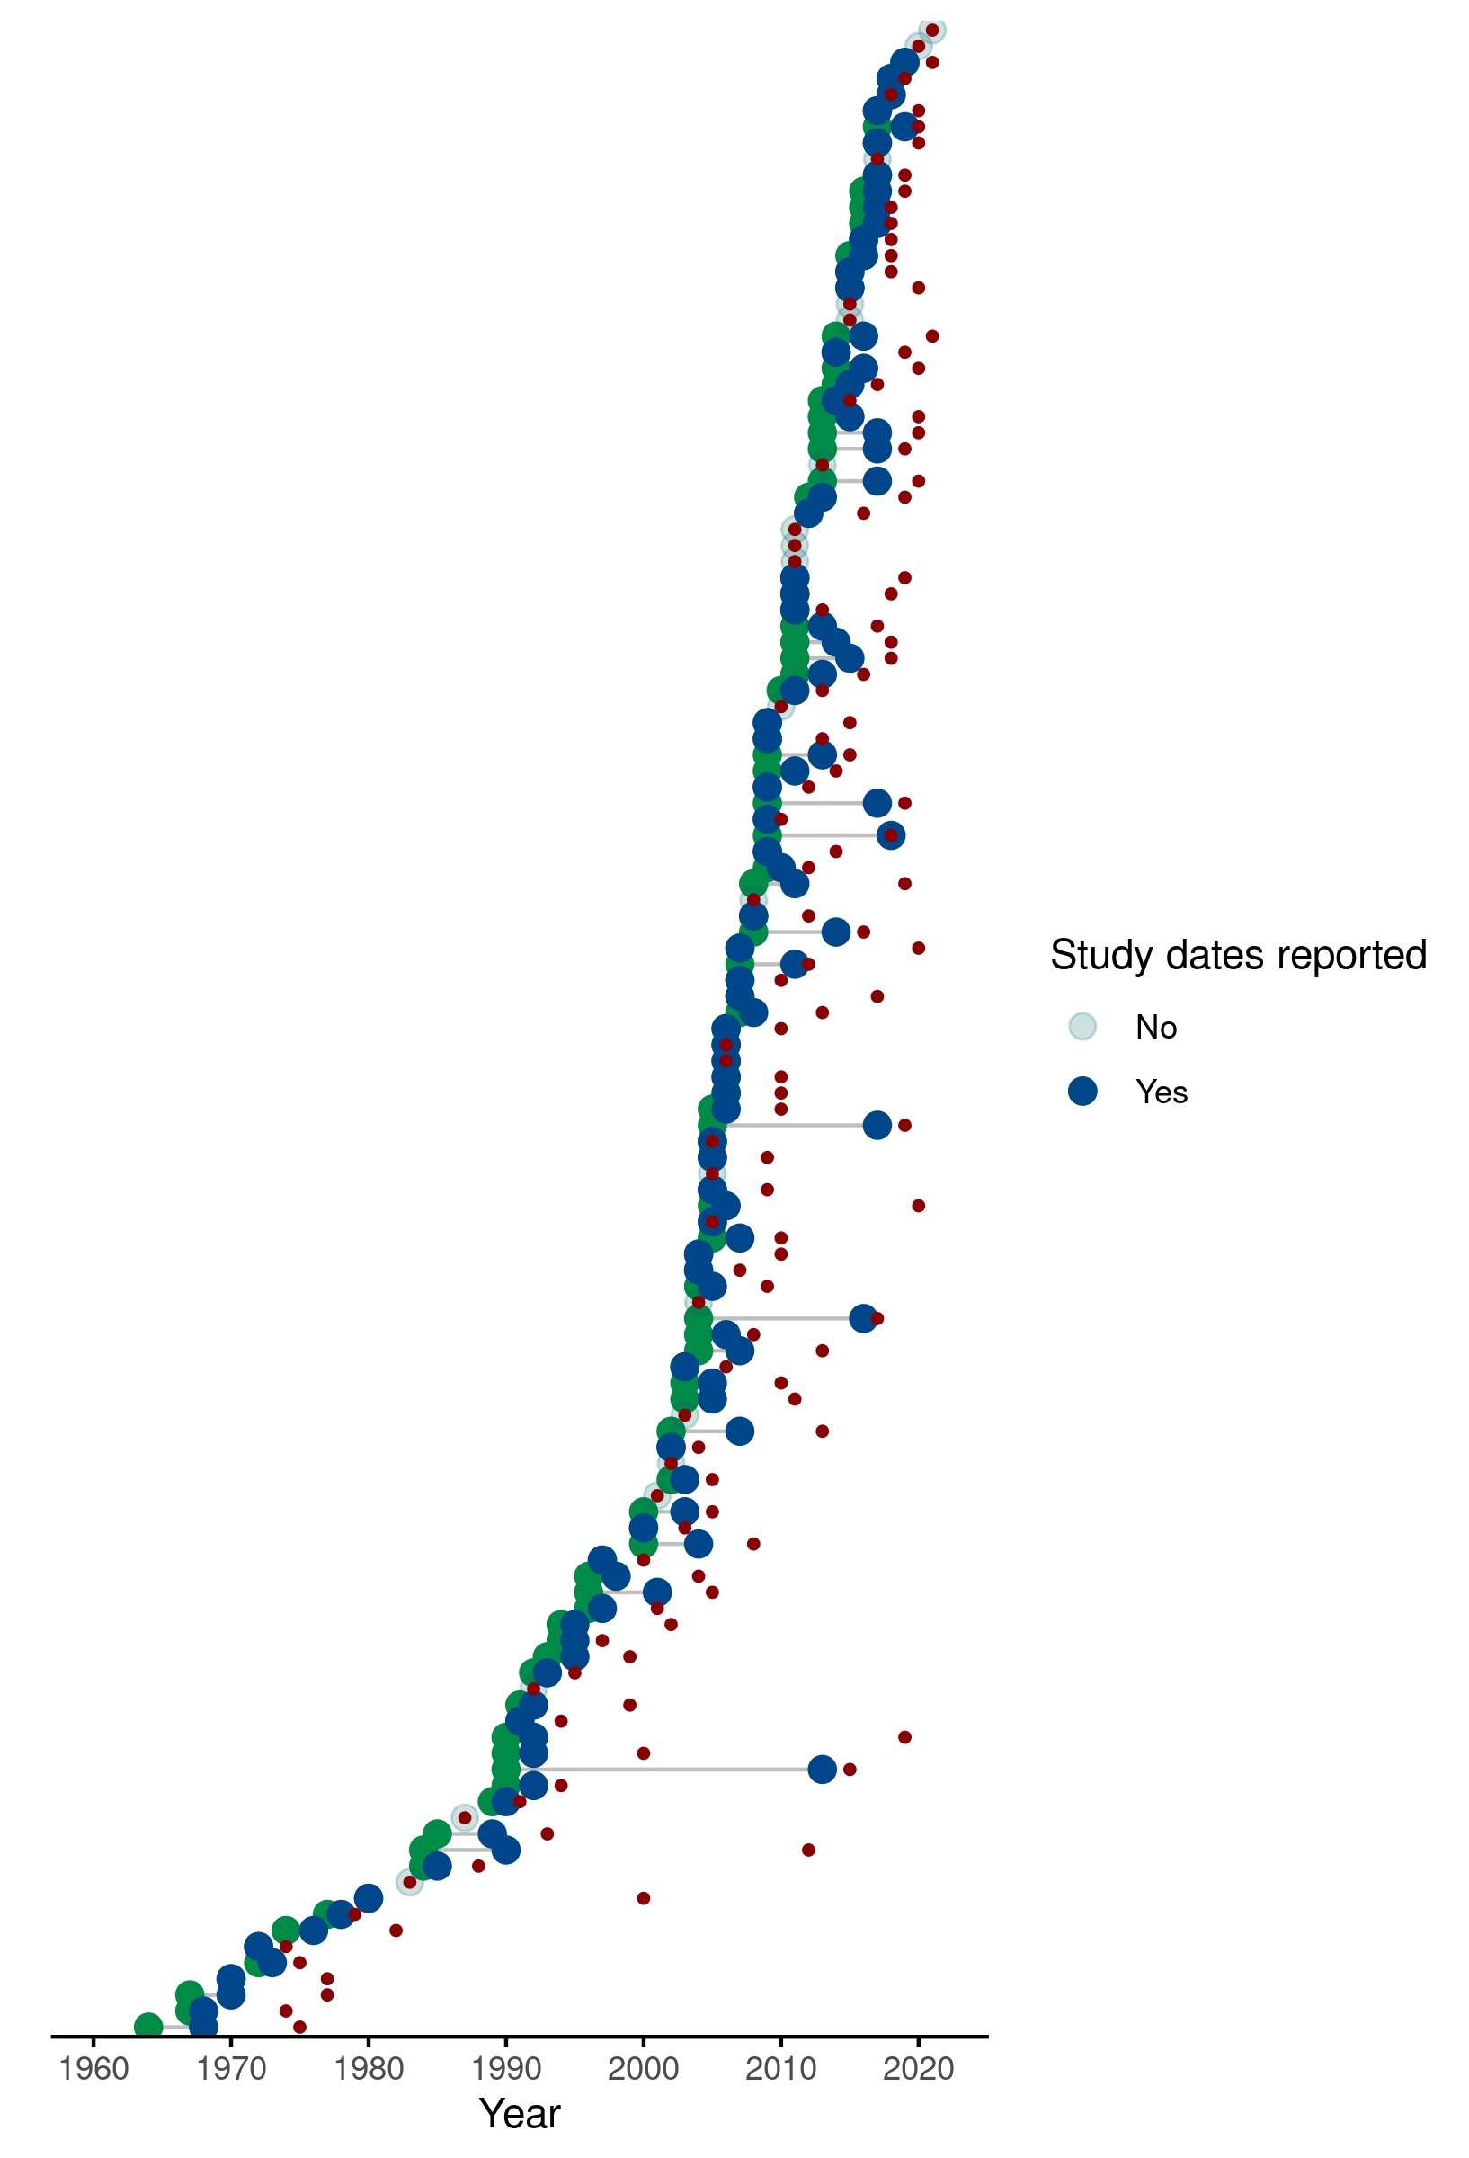

*Figure 1*: Each row represents one of the 126 included studies, green points designate the first year of data collection, blue points designate the end of data collection. For studies completed within one year the blue point completely overlies the green. Studies with a transparent grey point did not report the year in which trapping was conducted. The year of publication is shown by a red point.

## Location and habitats of rodent trapping studies to investigate potential biases

* Rodent trapping took place at 1,331 trap sites with at least one trap site recorded from 14 West African countries. No rodent trapping studies were identified from Gambia or Togo.
* Thirty-one (25%) studies reported trapping at a single study site, 46 (37%) studies trapped at between two and five study sites, the remaining 49 studies trapped at between six and 93 study sites. Trap sites were situated in 273 (19.3%) of 1414 level 2 administrative regions from the 14 West African nations. The areas with highest trapping activity included the capital cities of Niger (Niamey), Sierra Leone (Freetown), Senegal (Dakar), Mali (Bamako) and Ghana (Accra) and the largest cities of Côte d’Ivoire (Abidjan) and Benin (Cotonou). Outside of these cities, Northern Senegal (Fatique, Thies, Saint-Louis and Kedougou), Southern Guinea (Kindia and Nzerejore), Edo and Osun States in Nigeria and Eastern Sierra Leone were the most intensively studied regions (see Figure 2 - Panel A).
* Greater numbers of trap nights were conducted in areas with higher population densities (*R2* = 0.167). In particular Mauritania, Northern Senegal, Eastern Sierra Leone, Eastern Guinea and South West Nigeria were trapped at increased rates than would be expected based on their population densities. South West Nigeria, Northern Nigeria, Liberia, Côte d’Ivoire, Ghana, Niger and Burkina Faso were trapped at lower rates (see Figure 2 - Panel B) .
* No studies reported trap habitats with reference to a standardised habitat classification scheme.
* Extracted habitat types were grouped into 30 categories (see Supplementary Material 2 for the habitat dictionary). At least one habitat was recorded for 17,122 trap sites (95%), with two or more habitats for a single trap site recorded for 4,403 (24%) sites. Single trap sites could span multiple habitat types resulting in 22,202 distinct habitat and trap sites.
* The most commonly trapped sites were in or around buildings (29%), in areas described as the rodents “natural habitat” (24%), in agricultural areas (13%) (e.g. rice fields, palm plantations), forests (8%) and in the area surrounding buildings (4%).
* Explore whether trap sites are more likely to have been conducted within high population regions or whether there is an association with trap location and habitat as obtained from remote sensing data (Need to do this. The remote sensing data will be matched to the trap dates there will be several years between the trapping and data this is compared to it seems impractical to try and get annual population estimates or land classification so this will be chosen pragmatically)



*Figure 2*: **Panel A:** Map of West Africa, countries where rodent trapping has occurred are mapped to level 2 administrative areas (where available). These regions are coloured by the total number of trap nights performed at trap sites within their boundaries. **Panel B:** (n.b. will not include map in final manuscript) The number of trap nights conducted is associated with a regions population density. The population density for all regions in West Africa is shown in the yellow box plot, the population density and trap night density for each region is show on the purple scatterplot. The line of best fit is a GAM model not incorporating spatial interactions. The map panel on the right is the product of the GAM model incorporating spatial interactions. **Panel C:** For each of the 10 land cover classes from the ESA dataset we measure the proportion of 300m2 pixels within a level 2 administrative area. Zoonotic trapping studies occurred in regions over-representative for Cropland, Mosaic landscapes and Shrubland while being under-representative for Bare and Sparse vegetation land cover classes.

## Rodent presence, absence, abundance

* 73,164 small mammals were trapped (592 were trapped outside of West African countries), 2,830 (4%) trapped individuals were identified to order level (Rodentia), 7,760 (11%) were identified to genus level, the remaining 62,574 (85%) were identified to species level.
* In studies reporting the number of trap nights the median trap success rate of traps placed in or around buildings was 13% (IQR 6-24%), this compares to a median trap success rate of 3% (IQR 1-9%) in other habitats.
* Of the 147 distinct identified species trapped (see Supplementary Material 3) the majority were from the order Rodentia (112). Muridae (82) represented the largest family of rodents, followed by, Sciuridae (10), Gliridae and Nesomyidae (both 6), Ctenodactylidae and Anomaluridae (2) and Dipodidae, Hystricidae and Thryonomidae (all 1). The remaining 34 species came from the orders of the Soricomorpha (30), Erinaceomorpha (2) and Afrosoricida (1).
* The most commonly trapped genera of rodents were *Mastomys sp.* (27,079, 37.7%), *Rattus sp.* (11,472, 16.1%), *Mus sp.* (8,624, 12.0%), *Arvicanthis sp.* (5,821, 8.1%) and *Praomys sp.* (5,409, 7.5%). At species level *Mastomys natalensis* (11,116, 17.4%), *Rattus rattus* (9,959, 15.6%), *Mastomys erythroleucus* (7,386, 11.6%), *Mus musculus* (6,245, 9.8%), *Arvicanthis niloticus* (5,497, 8.6%), *Mastomys huberti* (4,699, 7.4%) and Praomys daltoni (1,854, 2.9%) were the most commonly trapped.
* Locations of points for the presence or absence of the seven most commonly trapped species are displayed in Figure 3 (left column). These are able to identify locations of absence within an individual species documented range. Whether an absence represents a “true absence” (i.e. not present at this location) or a “pseudo absence” (i.e. not detected at this location) should be interpreted with consideration to the trapping effort at the site. This is compared to reported presence obtained from GBIF (centre column) and IUCN species range data (left column) in Figure 3.

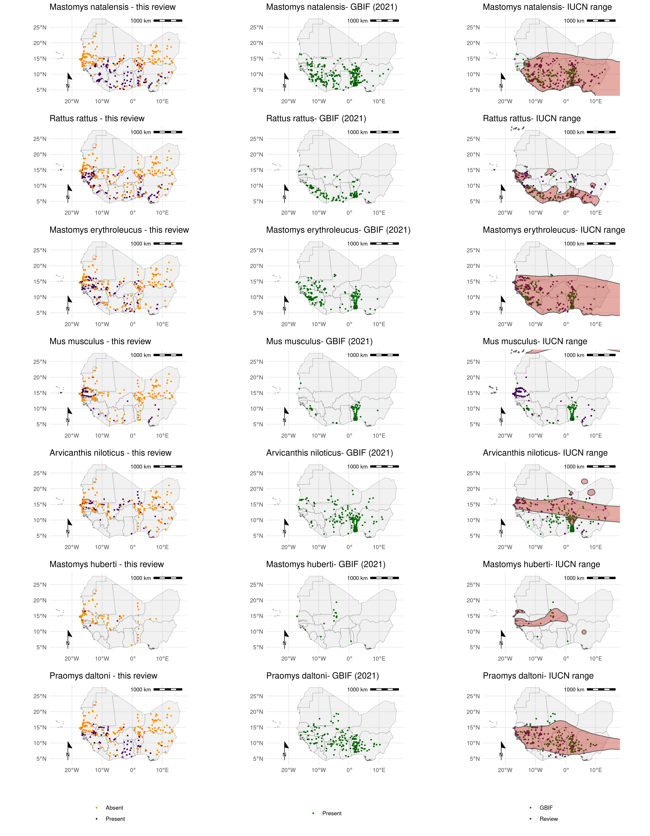

*Figure 3*: Each row corresponds to a single rodent species. The column on the left shows the presence and absence of a rodent species from the individual studies included in this review. The centre column shows the presence of a rodent species obtained from GBIF (September 2021) for records where longitude and latitude have been provided. The right column shows the range of rodent species as proposed by the IUCN (2021) (red shaded area), overlaid are the presence points from both this review and GBIF records.

## Pathogen presence and absence

* Sixty-two studies presented data on microorganisms that infect or are carried by small mammal species in West Africa.
* Seven studies solely investigated pathogens of rodents, including Hydatigera species (previously Taenia species) and Trichuris species.
* Fifty-five studies investigated microorganisms that were potentially zoonotic pathogens. Thirty-two microorganisms were tested for, 8 of these were defined at species level, with the remaining 24 at levels of higher taxonomic classification.
* Thirty-two studies used Polymerase Chain Reaction (PCR) to detect the presence of 22 different species or families of microorganisms in 21,953 rodent samples. Eleven studies used antibody or antigen based molecular tests to detect the presence of 9 different species or families of microorganisms in 11,430 samples. Eight studies conducted histological or direct visualisation assays of samples for 11 parasitic or bacterial species in 11,229 samples. Three studies performed direct culture of Lassa mammarenavirus or Leishmania species to detect the presence of the pathogen in 643 samples.
* The most common microorganisms assessed for using PCR were Lassa mammarenavirus or other Arenaviridae (31%) the bacteria *Borrelia sp.* (11.3%) and *Bartonella sp.* (6.5%), followed by Usutu virus (6.4%) and Hantaviridae (5.6%). The most common pathogens assessed for with serology were *Lassa mammarenavirus* or other Arenaviridae (78%), *Toxoplasma gondii* (10.6%), *Borrelia sp.* (6.3%) and *Leptospirosis sp.* (2.2%). The most common pathogens assessed for with histology or direct visualisation were *Borrelia sp.* (48.7%), *Schistosoma sp*. (20.4%) and other parasites. All studies using direct culture were investigating either *Lassa mammarenavirus* (81%) or *Leishmania sp.* (19%).
* Most studies tested for a single microorganisms (39), with 16 studies testing for two or more microorganisms. The most frequently tested for microorganisms were *Lassa mammarenavirus* (28%) or members of the Arenaviridae family (16%), the spirochete bacteria *Borrelia sp.* was investigated in 8 studies, *Bartonella sp.* and *Toxoplasma gondii* were investigated in 4 each, the remaining 25 microorganisms were reported in three or fewer studies.
* There is spatial heterogeneity in the location of trapped rodents that were tested for the four most commonly assayed microorganisms.
* The presence and absence of Arenaviridae, predominantly *Lassa mammarenavirus*, in rodents was assessed in Guinea, Sierra Leone, Mali, Côte d’Ivoire, Benin and Nigeria. The known reservoir species of this zoonotic pathogen *Mastomys natalensis* was additionally detected in Senegal, Guinea-Bissau, Burkina-Faso and Niger with likely presence in Liberia and Togo. Arenaviridae were detected in rodents from 17 of 54 species or genera assayed from Guinea, Sierra Leone, Mali, Côte d’Ivoire, Ghana and Nigeria, no positive rodents were detected in Benin (Figure 4 top row).
* The presence and absence of *Borrelia sp.* was investigated in Senegal, Mauritania, Mali, Niger and Benin. Microorganisms of this genera were detected from samples in Mali with negative samples obtained from Senegal, Mauritania, Niger and Benin (Figure 4 second row). *Borrelia sp.* were detected in 8 of 44 species or genera of rodents assayed.
* The presence and absence of *Bartonella sp.* was investigated in Senegal, Mali and Nigeria with positive samples obtained at most sites from all three countries (Figure 4 third row). *Bartonella sp.* were detected in 11 of 11 specis or genera of rodents assayed.
* The presence of *Toxoplasma gondii* was only investigated in Senegal with relatively high proportions of positive samples at all sites (Figure 4 fourth row). *Toxoplasma gondii* was detected in 6 of 8 rodent species assayed.

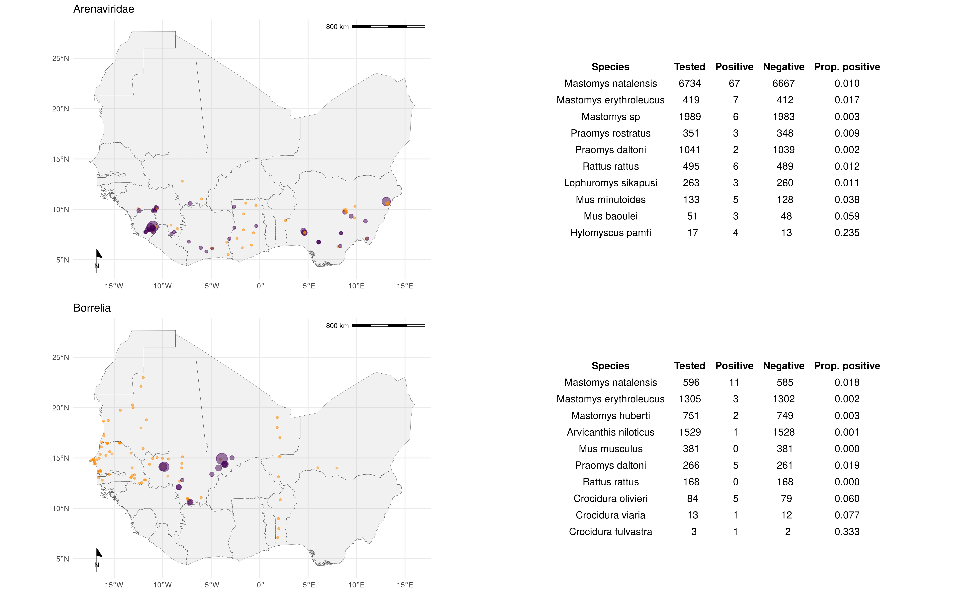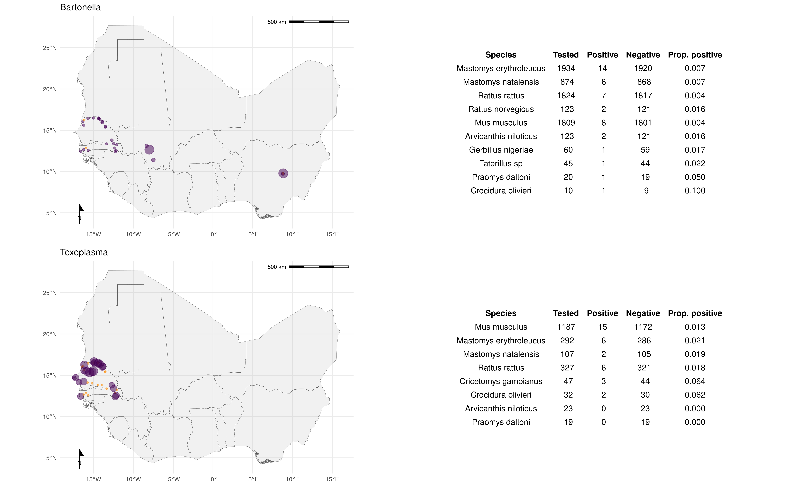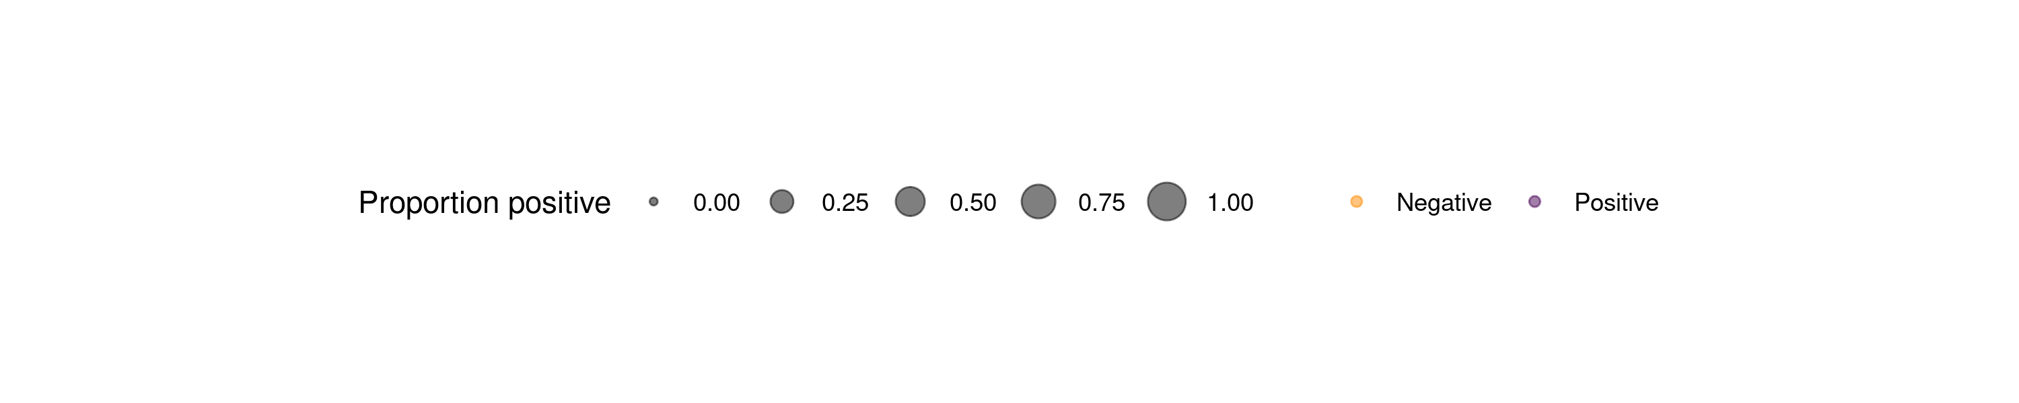

*Figure 4*: Presence/absence plots at each unique trapping site for the four most commonly assayed microorganisms Arenaviridae (top), *Bartonella sp.* (second row), *Borrelia sp.* (third row) and *Toxoplasma gondii* (fourth row). The tables to the right of each map highlight the 10 (or number applicable) most commonly positive and tested rodent species and genera assayed.

## Host-pathogen associations

* Ninety-seven rodent species were investigated for the presence of a zoonotic pathogen. 42,940 assays were performed on 32,014 individual rodents.
* The rodent species most commonly assayed for zoonotic pathogens were, *Rattus rattus* (n = 2,977) assessed for 24 pathogens, *Mus musculus* (n = 3,402) for 23, *Mastomys natalensis* (n = 7,189) and *Mastomys erythroleucus* (n = 3,013) both 19 and *Arvicanthis niloticus* (n = 3,840) for 18.
* All remaining species were investigated for 10 or fewer pathogens.
* *Lassa mammarenavirus* was detected in 414 *Mastomys natalensis*, 9 *Mastomys erythroleucus*, 5 *Hylomyscus pamfi* and 3 *Mus baoulei* through PCR. In serological assays, evidence of prior infection or acquisition of maternal antibodies to *Lassa mammarenavirus* was detected in 465 *Mastomys natalensis*, 361 *Mastomys sp.*, 6 *Mus musculus* and 4 *Rattus rattus*. From direct viral culture 19 *Mastomys natalensis*, 2 *Rattus rattus* and 1 *Mus minutoides* were found to be infected with *Lassa mammarenavirus*. *Bartonella sp.* were detected in; 113 *Mastomys natalensis*, 50 *Mastomys erythroleucus*, 39 *Rattus norvegicus*, 16 *Rattus rattus* and 13 individuals of 7 further species through PCR.
* *Borrelia sp.* infections were identified through PCR in 110 individuals; 37 *Mastomys erythroleucus*, 12 *Mus musculus*, 11 *Mastomys huberti* and *Praomys daltoni*. The remaining 39 positive results were from 9 further species. In serological assays, 47 *Mastomys natalensis*, 12 *Mastomys erythroleucus* and 8 *Praomys daltoni* were positive, with the remaining 11 positive individuals from three further species. Most *Borrelia sp.* infections were identified through histology or direct visualisation with, 243 *Arvicanthis niloticus*, 102 *Mastomys natalensis*, and 78 *Mastomys huberti* along with a further 64 individuals from 8 species infected.
* Finally, *Toxoplasma gondii* was detected through PCR in 89 Mus musculus, 13 *Cricetomys gambianus*, 5 *Crocidura olivieri* and 3 *Rattus rattus*. From serological assays evidence of prior infection was found in 25 *Mus musculus*, 46 *Mastomys erythroleucus*, 4 *Rattus rattus* and *Mastomys natalensis*. A single *Mus musculus* and *Rattus rattus* were found to be infected using histology and direct visualisation.
* Thirty-eight species of Rodentia, 3 species of Soricomorpha and 2 species of Erinaceomorpha that were tested for potential pathogens had entirely negative results.

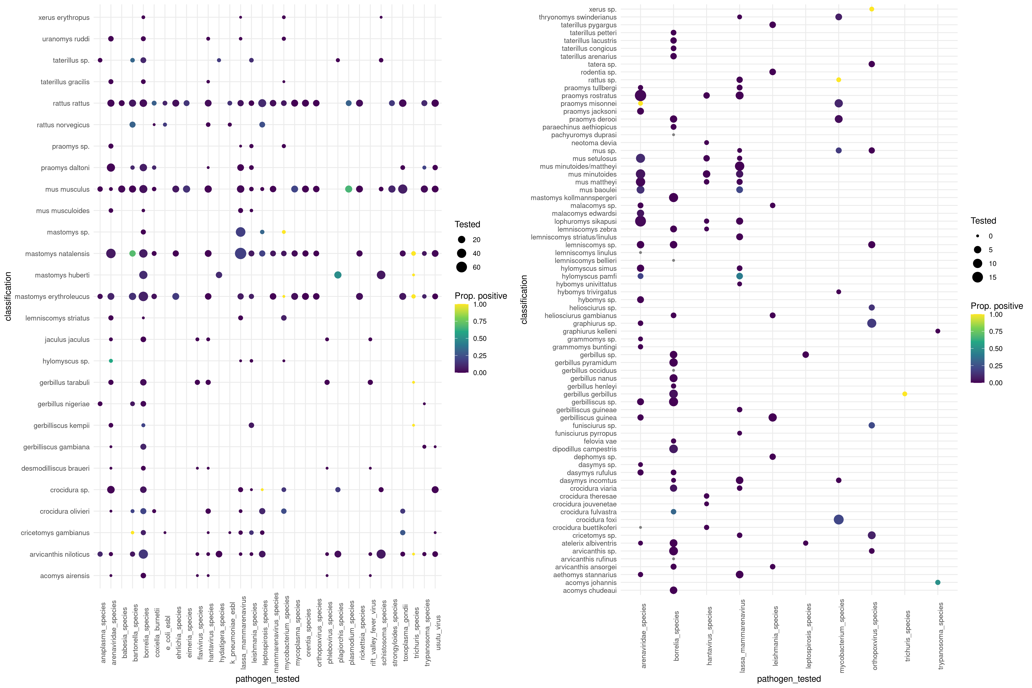

Figure 5 - Matrix heat plot Y - rodent species/genera, X - pathogen species/genera. Colour relates to proportion positive (Perhaps use bivariate colour to also highlight the number of test performed in that species).

## Discussion

* 124 trapping studies were identified across 14 West African countries. 54 studies provided additional information about potential zoonotic pathogens of trapped rodents.

Albery, Gregory F., and Daniel J. Becker. 2021. “Fast-Lived Hosts and Zoonotic Risk.” *Trends in Parasitology* 37 (2): 117–29. <https://doi.org/10.1016/j.pt.2020.10.012>.

Bovendorp, Ricardo S., Robert A. MCCleery, and Mauro Galetti. 2017. “Optimising Sampling Methods for Small Mammal Communities in Neotropical Rainforests.” *Mammal Review* 47 (2): 148–58. <https://doi.org/10.1111/mam.12088>.

Burgin, Connor J, Jocelyn P Colella, Philip L Kahn, and Nathan S Upham. 2018. “How Many Species of Mammals Are There?” *Journal of Mammalogy* 99 (1): 1–14. <https://doi.org/10.1093/jmammal/gyx147>.

Catalano, Stefano, Elsa Leger, Cheikh B. Fall, Anna Borlase, Samba D. Diop, Duncan Berger, Bonnie L. Webster, et al. 2020. “Multihost Transmission of Schistosoma Mansoni in Senegal, 2015-2018.” *Emerging Infectious Diseases* 26 (6): 1234–42. <https://doi.org/10.3201/eid2606.200107>.

Dobson, F Stephen, and Madan K Oli. 2007. “Fast and Slow Life Histories of Rodents.” *Rodent Societies: An Ecological and Evolutionary Perspective*, 99–105. <https://www.jstor.org/stable/42902037>.

Facility, GBIF: The Global Biodiversity Information. 2021. “The Global Biodiversity Information Facility.” <https://www.gbif.org/>.

Fichet-Calvet, Elisabeth, Emilie Lecompte, Frederic Veyrunes, Patrick Barrière, Violaine Nicolas, and Kékoura Koulémou. 2009. “Diversity and Dynamics in a Community of Small Mammals in Coastal Guinea, West Africa.” *Belgian Journal of Zoology* 139 (2): 93–102. <http://www.vliz.be/nl/open-marien-archief?module=ref&refid=204614>.

Fischer, Christina, Christoph Gayer, Kornélia Kurucz, Friederike Riesch, Teja Tscharntke, and Péter Batáry. 2018. “Ecosystem Services and Disservices Provided by Small Rodents in Arable Fields: Effects of Local and Landscape Management.” *Journal of Applied Ecology* 55 (2): 548–58. <https://doi.org/10.1111/1365-2664.13016>.

Gibb, Rory, Gregory F. Albery, Nardus Mollentze, Evan A. Eskew, Liam Brierley, Sadie J. Ryan, Stephanie N. Seifert, and Colin J. Carlson. 2021. “Mammal Virus Diversity Estimates Are Unstable Due to Accelerating Discovery Effort.” Preprint. Ecology. <https://doi.org/10.1101/2021.08.10.455791>.

Gibb, Rory, David W. Redding, Kai Qing Chin, Christl A. Donnelly, Tim M. Blackburn, Tim Newbold, and Kate E. Jones. 2020. “Zoonotic Host Diversity Increases in Human-Dominated Ecosystems.” *Nature* 584 (7821): 398–402. <https://doi.org/10.1038/s41586-020-2562-8>.

Han, Barbara A., Andrew M. Kramer, and John M. Drake. 2016. “Global Patterns of Zoonotic Disease in Mammals.” *Trends in Parasitology* 32 (7): 565–77. <https://doi.org/10.1016/j.pt.2016.04.007>.

Han, Barbara A., John Paul Schmidt, Sarah E. Bowden, and John M. Drake. 2015. “Rodent Reservoirs of Future Zoonotic Diseases.” *Proceedings of the National Academy of Sciences* 112 (22): 7039–44. <https://doi.org/10.1073/pnas.1501598112>.

Jones, Kate E., Nikkita G. Patel, Marc A. Levy, Adam Storeygard, Deborah Balk, John L. Gittleman, and Peter Daszak. 2008. “Global Trends in Emerging Infectious Diseases.” *Nature* 451 (7181): 990–93. <https://doi.org/10.1038/nature06536>.

Morse, Stephen S, Jonna AK Mazet, Mark Woolhouse, Colin R Parrish, Dennis Carroll, William B Karesh, Carlos Zambrana-Torrelio, W Ian Lipkin, and Peter Daszak. 2012. “Prediction and Prevention of the Next Pandemic Zoonosis.” *The Lancet* 380 (9857): 1956–65. <https://doi.org/10.1016/S0140-6736(12)61684-5>.

Pigott, David M, Nick Golding, Adrian Mylne, Zhi Huang, Andrew J Henry, Daniel J Weiss, Oliver J Brady, et al. 2014. “Mapping the Zoonotic Niche of Ebola Virus Disease in Africa.” *eLife* 3 (September): e04395. <https://doi.org/10.7554/eLife.04395>.

Smith, Katherine F., Michael Goldberg, Samantha Rosenthal, Lynn Carlson, Jane Chen, Cici Chen, and Sohini Ramachandran. 2014. “Global Rise in Human Infectious Disease Outbreaks.” *Journal of The Royal Society Interface* 11 (101): 20140950. <https://doi.org/10.1098/rsif.2014.0950>.

Wille, Michelle, Jemma L. Geoghegan, and Edward C. Holmes. 2021. “How Accurately Can We Assess Zoonotic Risk?” Edited by Andy P. Dobson. *PLOS Biology* 19 (4): e3001135. <https://doi.org/10.1371/journal.pbio.3001135>.